A Project Report

On

**Wireless Notice Board Using Bluetooth and Arduino**

Course Code: CSE 416

Course Title: Mobile and Wireless Communication Sessional

Level: 4, Semester: I

**Team Members:**

Md. Mostafijur Rahman

Student ID: 1902073

Ananya Das Gupta

Student ID: 1902051

Hasi Rani Roy

Student ID: 1902031

Mostakim Ara Jaba

Student ID: 1802048

Md. Masum Rana

Student ID: 1902005

Department

of

Computer Science and Engineering



Hajee Mohammad Dasnesh Science and Technology

University, Dinajpur-5200

***Abstract: The proposed method consists of electronic notice board that is controlled by an android device and displays a message on it. Traditionally, there were notice boards where any information or notice had to be stick daily. This becomes tedious and requires daily maintenance. The project overcomes this problem by introducing an electronic display notice board interfaced to an android device through Bluetooth connectivity. The Bluetooth receives the message from the Android device that is sent to an Arduino. Notice board is a primary thing in any institution/organization or public utility places like bus stations, railway stations and parks. But sticking various notices day-to-day is a difficult process. The Notice board is a common display for effective mode of providing information to the people, but this is not easy for updating the messages instantly. This project deals about an advanced Hi-Tech wireless Notice Board. This system is enhanced to display the latest information through an Android application of smart phones or tablet.***

## INTRODUCTION

In this proposed method, the development of a simple and low-cost wireless Android based notice board is presented. The proposed system uses either Bluetooth or Wi-Fi based wireless serial data communication in displaying messages on a remote digital notice board.

Android based Application programs available for Bluetooth and Wi-Fi communication for personal digital assistant (PDA) devices are used for transmitting the alpha-numeric text messages. Using the Bluetooth or Wi-Fi based serial data communication technique, the corresponding transceiver module has been interfaced with microcontroller board at the receiver end. For this purpose, a low- cost microcontroller board (Arduino Uno) is programmed to receive alphanumeric text messages in any of the above selected communication modes. The proposed system will help in reducing the human effort, paper, printer ink and cost for manual changing of the notices.

The development of cellular networks in the 1970’s for increasing the lack of frequencies in the radiotelephone services which in turn lead to introduction of AMPS (Advanced Mobile Phone System) where the transmission was analog based. This was known to be the first generation in cellular networks. The second generation was based on digital transmission and was called with various abbreviations as GSM (Global System for Mobile communications), ERMES (European Radio Messaging System).

Various Cordless telephone standards were also introduced during this time only. The third generation has risen with the unification of different technologies; some of them which are popularly known are FPLMTS (Future Public Land Mobile Telecommunications System), UMTS (Universal Mobile Telecommunication System), and IMT-2000 (International Mobile communication). These days, BLUETOOTH technology has become one the most popular medium for wireless data transfer. It has a wide range and is efficient in its work

## LITERATURE SURVEY

1. *Ramya R, Bavithra N, Priyanka M, “Wireless E-notice board using Bluetooth technology” This paper explains E-notice board with the help of Bluetooth technology.*

This document deals with an innovative rather an interesting manner of intimating the message to the people using a wireless electronic display board which is synchronized using the Bluetooth technology. This will help

us in passing any message almost immediately without any delay just by sending a SMS which is better and more reliable than the old traditional way of passing the message on notice board. This proposed technology can be used incolleges many public places, malls or big buildings to enhance the security system and also make awareness of the emergency situations and avoid many dangers.

1. *Dharmendra Kumar Sharma, Vineet Tiwari, “Small and medium range wireless electronic noticeboard using Bluetooth and ZigBee” this paper introduces Notice Board using Bluetooth and ZigBee technology.*

When information exchange occurs between people via a network, then authentication and security of data have more priority. This paper introduces a low cost, handheld, wireless electronic notice board by using Atmel’s ATmega32 microcontroller and different wireless technologies (Bluetooth and ZigBee) and their performance analysis based on the parameter such as range, BER (bit error rate), RSSI (Received signal strength indicator), signal attenuation and power consumption. The notice board receives serial data from wireless module receiver and displays it on the graphical liquid crystal display. We have realizeda common communication receiver hardware for notice board having compatibility with both wireless modules i.e., Bluetooth and ZigBee. We used KS0108 based 128x64 graphical LCD as display element.

1. *M. Abila Mary, B. Pavithra, R. Sangeetha, Prof.T.C. Subbu Lakshmi, “GSM based wireless noticeboard using Arduino” In this paper built a Noticeboard using GSM technology.*

The GSM based notice board is aimed at the colleges and universities for displaying day-to-day information continuously or at regular intervals during the working hours. Being GSM-based system, it offers flexibility to display flash news or announcements faster than the programmable system.

* 1. To develop a GSM based notice board whose contents can be updated through an SMS which realized through an embedded system with microcontroller.
  2. To design a project simple, easy to install, user friendly system, which may receive and display notice in a very specific manner.
  3. SMS based notice board incorporating the widely used GSM to facilitate the communication of displaying message on notice board via user’s mobile phone .
  4. SIM 800 GSM modem with a SIM card is interfaced to the ports of the Arduino with the help of AT commands.

1. *Pallavi M. Banait, Nikita P. Bakale, Mayuri S. Dhakulkar, Bhushan S. Rakhonde, “Cost effective Android based wireless notice board” IJETER International Journal of Emerging Technologies in Engineering Research.*

In the day-to-day life, smart phone is gaining a wide range of importance in its usage and is portable. Thus, an android smart phone can be for the purpose. An android application is installed in the user’s smart phone which permits the transmission. At receiver end, a low-cost microcontroller board (Arduino Uno) is programmed to receive and display messages in any of the above communication mode. Using the developed system, two different applications for displaying messages on a remote digital notice board and wireless person calling has been implemented. The developed system will therefore aim in wirelessly sharing the information with intended users and also helps in saving the time and the cost for paper and printing hardware.

## PROPOSED METHODOLOGY

The proposed method consists of power supply, Arduino UNO, LED module, Bluetooth HC-05 and mobile application. After uploading the program in Arduino UNO, we will give them external power supply. Due to that all functions of equipment’s are on. At that time, we will pass the notice/SMS which we want using mobile. Then this notice/SMS will receive by Bluetooth. And by using Arduino this notice/SMS will display on digital notice board.

This proposed system in this project has many upcoming applications in educational institutions and organizations, crime prevention, traffic management, railways, advertisements etc. Been user friendly, long range and faster means of conveying information are major bolsters for this application. By using this proposed methodology, we can enhance the security system and also make awareness of the emergency situations and avoid many dangers.

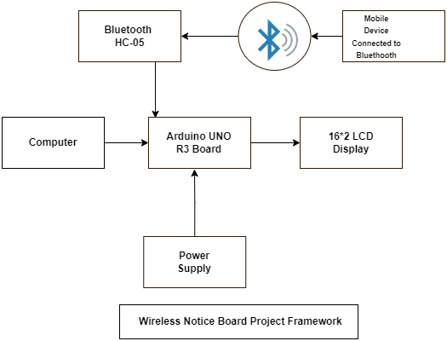

Fig 1 : Block diagram

1. ***HARDWARE IMPLEMENTATION***
2. 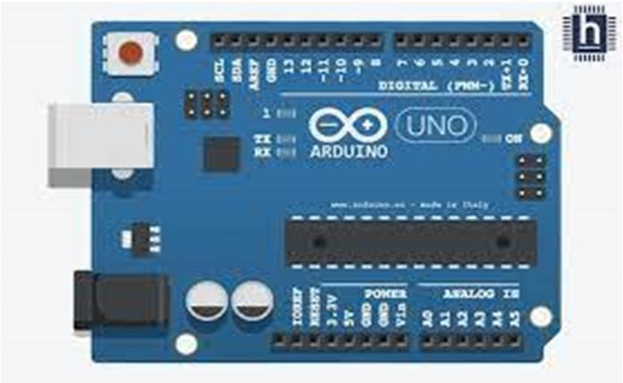*Arduino UNO R3 Board:*

Fig 2 : Arduino UNO R3 Board

Arduino board is the heart of our system. Entire functioning of system depends on this board. The Arduino Uno is a ATmega328p microcontroller board. This board has 14 digital input/output pins (6 as a PWM

outputs), 6 analog inputs, a 16 MHz crystal oscillator, a USB connection, a power jack, an ICSP header, and a

reset button.

1. *Bluetooth HC05*

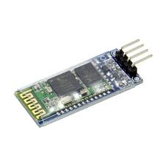

Fig 3 : Bluetooth HC05

Bluetooth Terminal is an Android application program that enables the Android PDAs to communicate simply with a Bluetooth device via a terminal. Bluetooth Terminal application program therefore enables the Android PDA to transmit (or receive ) the messages in either hexadecal (hex) or string format to (and from ) the connected Bluetooth devices. At the receiver end, the HC-05 module is interfaced with microcontroller that is programmed to store the received message and display that to the LCD screen. The HC-05 is a very cool module which can add two- way (full-duplex) wireless functionality. The Bluetooth module is used for transmitting data wirelessly from the transmitter to receiver. The HC-05 module works on the same principle but on the different operation. The HC-05 Bluetooth module has four pins: TX pin – Transmitting pin which is used to transmit the data. RX pin – the pin that receives data from the receiver. VCC pin – power supply pin. GND pin

– power supply pin.

1. *LCD*

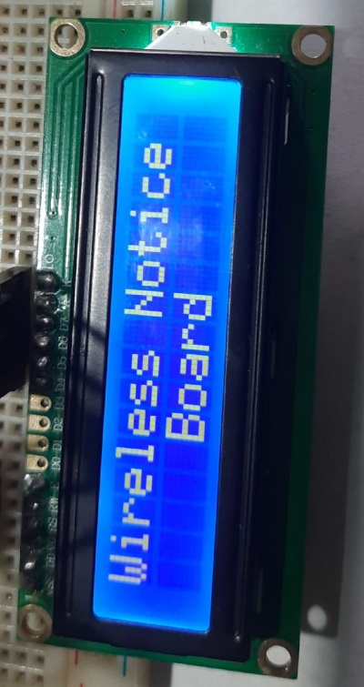

Fig 4 : 16x2 LCD Display

We utilize screen as display. LCD is utilized in a project to visualize the output of application. Liquid crystal displays (LCDs) have supplies which combine the properties of both liquids and crystals. With the liquid crystal material sand witched in between them, an LCD consists of two glass panels. The inner surface of the glass plates are covered with transparent electrodes that identify the character, symbols or patterns to be displayed and the polymeric layers are present in between the electrodes and the liquid crystal, which makes the liquid crystal molecules for maintaining a defined direction angle.

1. *Bread Board*

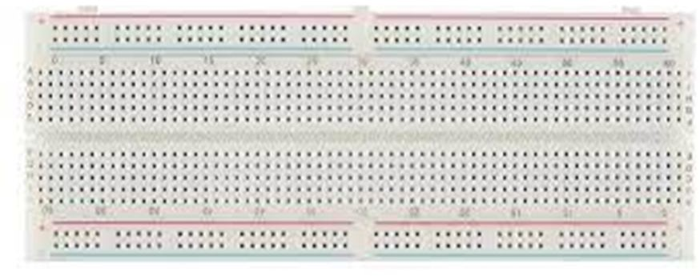

Fig 5 : Bread board

A breadboard (sometimes called plugblock) is used for building temporary circuits. It is useful to designers because it allows components to be removed and replaced easily. It is useful to the person who wants to build a circuit to demonstrate its action, then to reuse the components in another circuit.

1. 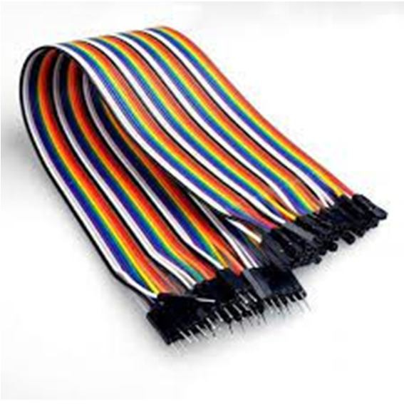*Jumper Wire:*

Fig 6 : Jumper wires

A jump wire is an electrical wire, or group of them in a cable, with a connector or pin at Stranded 22AWG jump wires with solid tips. Individual jump wires are fitted by inserting their "end connectors" into the slots provided in a breadboard

1. 10k or 100k potentiometer:

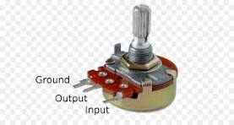

Fig 7: 100k Potentiometer

This is used to control the display on an Arduino, we can use the analog input from the potentiometer to adjust a certain parameter on the display, such as brightness, contrast, or scrolling speed.

## SOFTWARE REQUIREMENTS

1. *Arduino IDE*

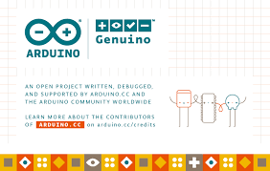

Fig 8 : Arduino IDE

Audino UNO R3 is the required software environment to program the Arduino by writing a code and uploading it to the Arduino. It also outputs the results for analysis using both a serial monitor and a serial plotter.

It is an Arduino software, making code compilation too easy. It is available for all operating systems i.e. MAC, Windows, and Linux, and runs on the Java Platform that comes with inbuilt functions and commands that play a vital role in debugging, editing, and compiling the code.

It is easy to use, it supports all the Arduino boards, it has a built-in library which is easy to use. The Arduino IDE is very user- friendly.

1. *Arduino Automation*

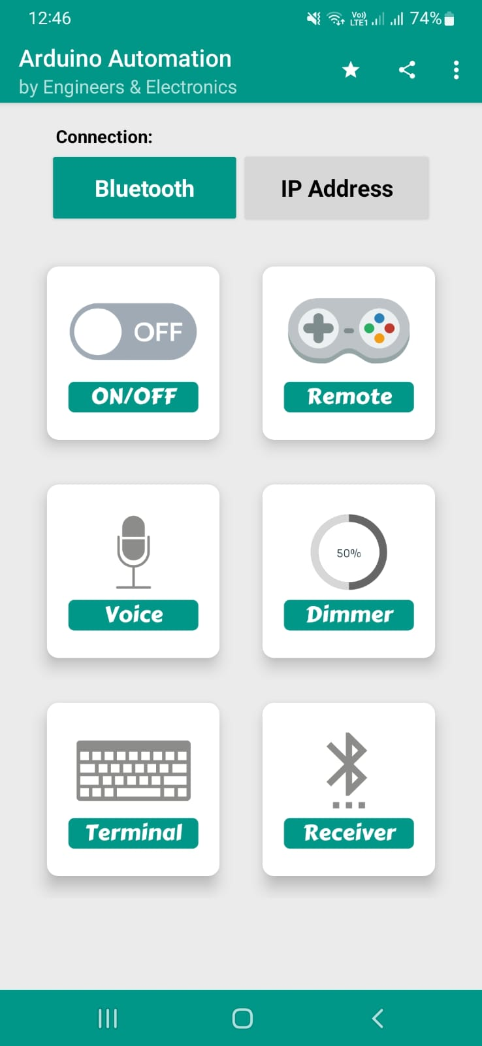

Fig 9 : Arduino automation app

It allows to control devices using your Arduino board (and similar boards) via Bluetooth or WIFI.BT Terminal is a terminal app with UART serial communication protocol that transmits & receives data wirelessly through Bluetooth connections. The app used for Robotics Communication, Configuring Bluetooth Modules (using AT Commands), and Home Automation.

1. ***Pin Connections***

**Arduino UNO R3 Board (Digital Pins):**

|  |  |
| --- | --- |
| **Pins** | **Connected to** |
| Pin no. 2 | LCD Pin D7 |
| Pin no. 3 | LCD pin D6 |
| Pin no. 4 | LCD pin D5 |
| Pin no. 5 | LCD pin D4 |

**Arduino UNO R3 Board (Power Supply):**

|  |  |
| --- | --- |
| **Pins** | **Connected to** |
| 5V | Positive of the breadboard |
| GND | Negative of the breadboard |

**Bluetooth HC05 Module pin connections:**

|  |  |
| --- | --- |
| **Pins** | **Connected to** |
| VCC | Positive of the breadboard |
| GND | Negative of the breadboard |
| TX | Pin no. 6 of Arduino |
| RX | Pin no. 7 of Arduino |

**LCD Display Pin connections:**

|  |  |
| --- | --- |
| **Pins** | **Connected to** |
| VDD | Positive of the breadboard |
| VSS | Negative of the breadboard |
| V0 | Output pin of Potentiometer |
| RS | Pin no. 8 of Arduino |
| RW | Negative of the breadboard |
| E | Pin no. 9 of Arduino |
| D4 | Pin 5 of Arduino |
| D5 | Pin 4 of Arduino |
| D6 | Pin 3 of Arduino |
| D7 | Pin 2 of Arduino |
| A | Positive of the breadboard |
| K | Negative of the breadboard |

**100k Potentiometer Pin Connections:**

|  |  |
| --- | --- |
| **Pins** | **Connected to** |
| Pin 1 | Positive of the breadboard |
| Pin 2 | V0 pin of LCD |
| Pin 3 | Negative of the breadboard |

1. ***RESULTS***

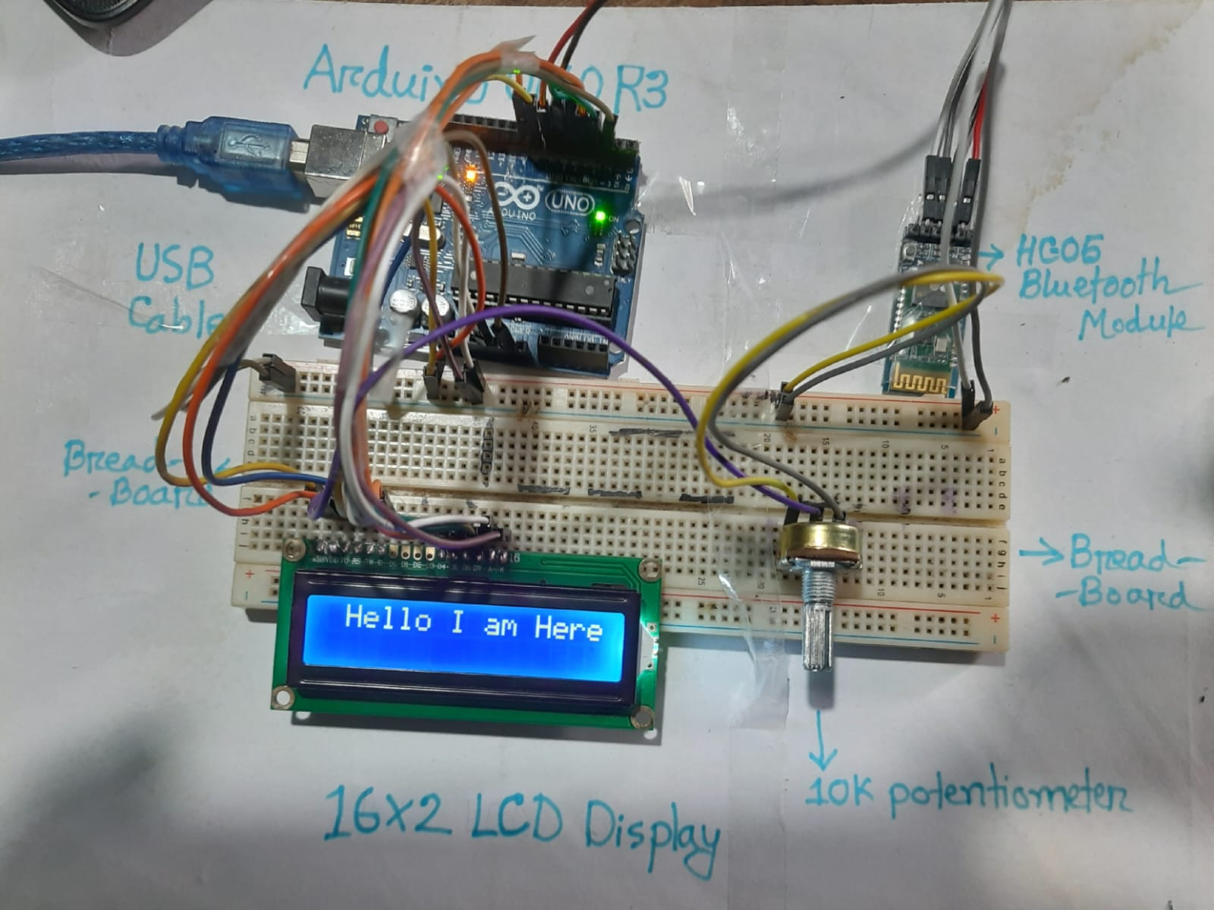

Fig 10 : Output

The result of the proposed method is a simple display of the message on the LCD screen. The output helps us to analyze that the result which was intended to achieve is so successful.

The output displayed on the screen is the message sent using HC-05 Bluetooth terminal. The sample message that will be displayed on the screen is seen where the message is on the interface.

***VII. CONCLUSION***

As the technology is advancing every day the display board systems are moving from Normal handwriting display to digital display. Further to Wireless display units . This project develops a wireless notice board system with Bluetooth connected to it, which displays the desired message of the user through an SMS in a most populated or crowded places. Here by introducing the concept of wireless technology in the Field of the communication. We can make our communication more efficient and faster, with greater efficiency. We can display the messages and with less errors and maintenance.

**REFERENCES**

[1] Ramya R, Bavithra N, Priyanka M “Wireless E-notice board using Bluetooth technology”, IJERT 2018.

[2] Dharmendra Kumar Sharma, Vineet Tiwari, Krishnan Kumar, et.al, “Small and Medium Range Wireless Electronics Notice Board using Bluetooth and Zig Bee”, IEEE INDICON 2015.

[3] M. Abila Mary, B. Pavithra, R. Sangeetha, Prof.T.C. Subbu Lakshmi “GSM based wireless noticeboards using Arduino”, IJARTET 2019.

[4] Pooja Pawar, Suvarna Langade, Mohini Bandgar “IOT Based Digital Notice Board using Arduino ATMega328”, IRJET 2019.

[5] Pallavi M. Banait, Nikita P. Bakale, Mayuri S. Dhakulkar, Bhushan S. Rakhonde “Cost effective Android based wireless notice board”, IJETER 2018.

[6] Gaurav Bhardwaj, Gunjan Sahu, Rajan Kumar Mishra “IOT based smart notice board”, IJERT 2022

## 